List of Holidays
April 2026 to March 2027
S.No | FESTIVALS | DATE | DAY
1 | Dr. B.R.Ambedkar Jayanti/ Vaisakhi | 14-April-26 | TUESDAY
2 | Buddhha Purnima | 01-May-2026 | FRIDAY
3 | Id-Ul-Zuha (Bakrid) | 27-May-26 | WEDNESDAY
4 | Shaheed Uddham Singh Martrydom Day | 31-July-26 | FRIDAY
5 | Independence Day | 15-August-26 | SATURDAY
6 | Rakshabandhan | 28-Aug-26 | FRIDAY
7 | Janmashtmi | 4 -Sep-26 | FRIDAY
8 | Shaheed Diwas / Haryana War Heroes’ Martrydom Day | 23-Sep-26 | WEDNESDAY
9 | Mahatma Gandhi Jayanti | 2-Oct-26 | FRIDAY
10 | Dussehra | 20 -Oct-26 | TUESDAY
11 | Maharishi Valmiki Jayanti | 26-Oct-26 | MONDAY
12 | Karva Chauth | 29-Oct-26 | THURSDAY
13 | Diwali | 08 -Nov-26 | SUNDAY
14 | Bhai Dooj | 11-Nov-26 | WEDNESDAY
15 | Vishwakarma Day | 24-Nov-26 | TUESDAY
16 | Guru Nanak Dev Jayanti | 24-Nov-26 | TUESDAY
17 | Christmas | 25 -Dec-26 | FRIDAY
18 | Makar Sankranti | 15 -Jan-27 | FRIDAY
19 | Republic Day | 26 -Jan-27 | TUESDAY
20 | Vasant Panchami | 11-Feb-27 | THURSDAY
21 | Maha Shivratri | 6-March-27 | SATURDAY
22 | Holi | 22-March-27 | MONDAY
2nd Saturday of every month will be an off ( in case of any change, prior information will be sent to the parents)
1st June to 30th June 2026
Diwali Break- 08th November to 11th November 2026 (Tentative)
Winter Break- As per Government instructions.


BARI
PATTIKALYANA
KARNAL
APOLLO INTERNATIONAL SCHOOL
ACADEMIC CALENDER
2026-2027
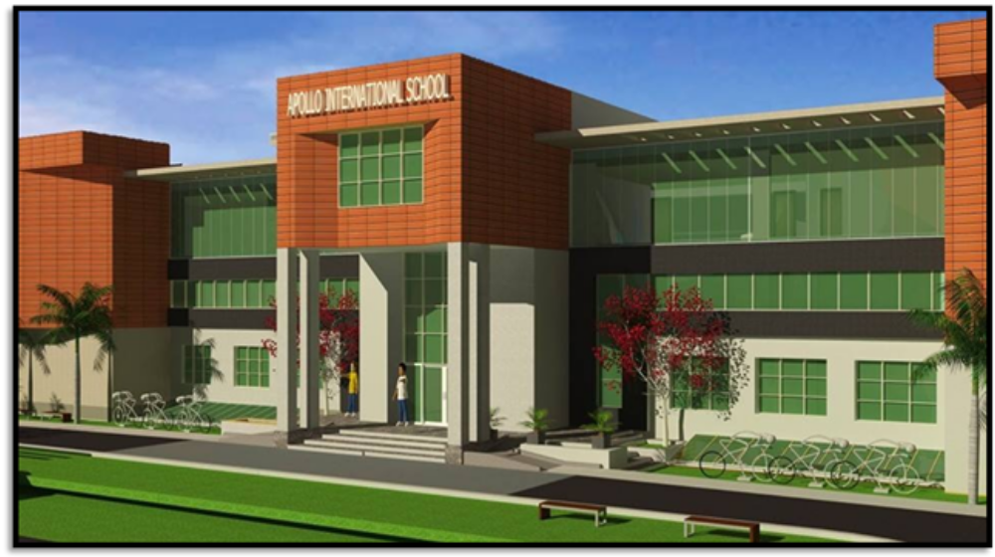
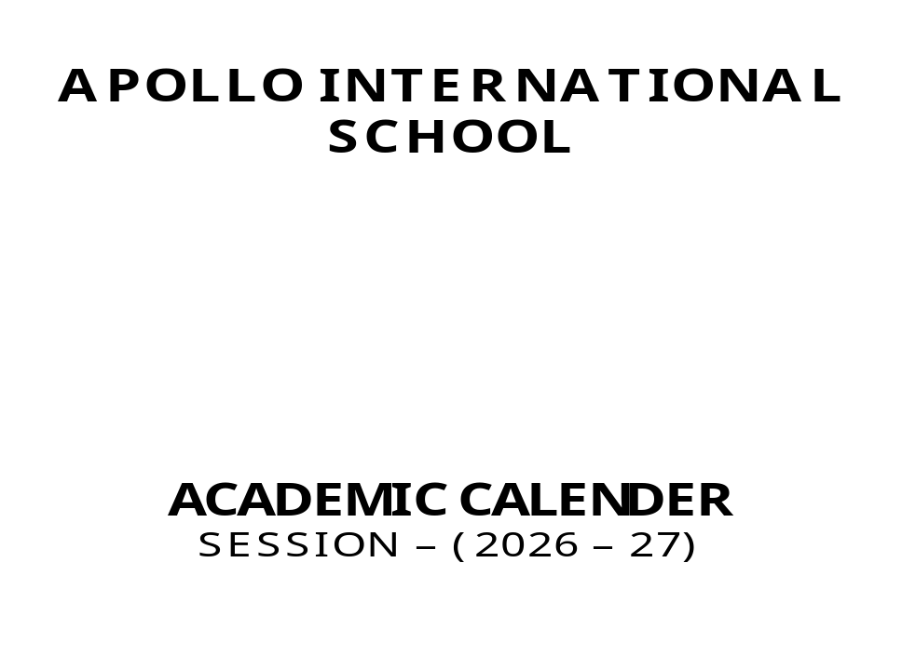
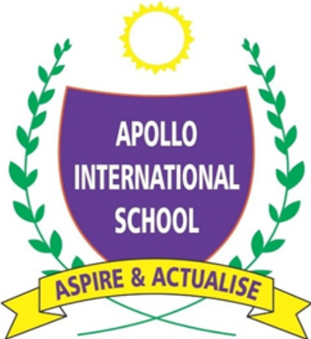

SPECIAL ASSEMBLY
Month | DATE | DAY | OCCASION | CLASS
April | 13-Apr-26  30 – Apr – 26 | Monday  Thursday | Baisakhi & Ambedker Jayanti  International Worker’s Day / Buddha Purnima | VIII  IX &XII
May | 09-May-26 | Saturday | Mother’s Day | EVENT
July | 25-Jul-26 | Saturday | KARGIL DIWAS | VII
August | 14-Aug-26 | Friday | Independence Day | X & XI
August | 27-Aug-26 | Thursday | Raksha Bandhan | III& IV
August | 29-Aug-26 | Saturday | Major Dhayan Chand B. Day | Sports Deptt.
September | 3-Sep-26 | Thursday | Janmashtami / Teacher’s Day | X, XI &XII
September | 11-Sep-25 | Thursday | Chicago Diwas | VI
 | 14- Sep-26 | Monday | Ganesh Chaturthi & Hindi Diwas | III & IV
October | 1-Oct-26 | Thursday | Gandhi & Shastri Jayanti (T.T)  Dussehra | X & XI
October | 8-Oct-25 | Wednesday | Indian Airforce Day | V
 | 19- Oct-25 | Monday | Dussehra | VIII
 | 24-Oct-26 | Saturday | Maharishi Valmiki Jayanti | VII
November | 31-Oct-26 | Saturday | Haryana Day | VI
November | 07-Nov-26 | Saturday | Diwali | IX
 | 23-Nov-26 | Monday | Guru Nanak Jayanti | X
December | 16-Dec-26 | Wednesday | Vijay Diwas(Army Day) | V
December | 24-Dec-26 | Thursday | Good Governance Day/Tulsi Diwas | VIII
December | 26-Dec-25 | Saturday | Veer Bal Diwas | III
January | 14-Jan-27  22-Jan-27 | Thursday  Thursday | Makar Sankranti  Vasant Panchami  Subhash Chandra Bose Birthday | IV  VII
January | 25-Jan-27 | Monday | Republic Day | VIII & IX
 | 10 – Feb -27 | Wednesday | Vasant Panchmi | VI
February | 14-Feb-27 | Saturday | Pulwama Day | VII

S.No. | Examination | Dates
1 | Periodic Test-1 | 11-05-2026 to 16-05-2026
2 | Periodic Test-2 | 27-07-2026 to 01-08-2026
3. | Term-1 | 14-09-2026 to 26-09-2026
4. | Periodic Test-3 | 16-11-2026 to 23-11-2026
IMPORTANT DATES OF THE ACADEMIC SESSION

Note:- PTM will be scheduled after each and every Periodic Test/Examination and notified.

INTER - CLASS ACTIVITIES AND COMPETITIONS (2026-27)
DATE/  DAY | III-VI | TEACHER – IN- CHARGE | VII-XII | TEACHER – IN- CHARGE
4/4/26  Saturday | Time Capsule Letter Writing | Respective Class Incharges | Time Capsule Letter Writing | Respective Class Incharges
18/4/26  Saturday | Story Telling with the help of Puppets (6-8) | Ms. Lata & Ms. Shallu | Just A Minute | Ms. Kusha
25/4/26  Saturday | Clock Making Activity | Ms. Sonia Gulati | Maths Quiz | Ms. Mohini
02/05/26  Saturday | Kho-Kho Match (GIRLS) | Ms. Mukesh | Inter House Cricket Match (BOYS) | Ms. Mukesh
16/05/26  Saturday | Kho-Kho Match (BOYS) | Ms. Mukesh | Inter House Cricket Match (GIRLS) | Ms. Mukesh
23/05/26  Saturday | Seminar on Basic Personal Hygiene | Ms. Lata & Ms. Sunita | Seminar on Adolescence Awareness Programme | Ms.Divya &  Ms. Anisha
30/05/26  Saturday | Talent Hunt Competition | Ms. Mamta Kori & Mr. Shiv | Talent Hunt Competition | Ms. Mamta Kori  Mr. Shiv
04/7/26  Saturday | Inter House Badminton Match | Ms. Mukesh | Inter- House Football Match | Ms. Mukesh
18/7/26  Saturday | Mock Youth Parliament | Ms. Reetu | Mock Youth Parliament | Ms. Shallu &  Ms. Kusha
25/07/26  Saturday | Plant Exhibition (Briefing)  - Exhibition To Be Held On PTM Day. | Ms. Divya & Respective Class Incharges | Art & Craft Exhibition (Briefing)  - Exhibition To Be Held On PTM Day. | Mr. Vaibhav  Respective Grade Incharges
01/08/26  Saturday | Science Fun Experiments | Ms. Divya | Science Fun Experiments | Ms. Anisha
22/08/26  Saturday | Rakhi & Craft Making | Mr. Vaibhav | Best Out of Waste | Mr. Vaibhav
19/9/26  Saturday | Inter House Basketball | Ms. Mukesh | Inter – House Badminton | Ms. Mukesh
26/09/26  Saturday | Science Exhibition (Briefing)  - Exhibition To Be Held On PTM Day. | Ms. Divya & Respective Class Incharges | Science & Robotics Exhibition (Briefing)  - Exhibition To Be Held on PTM Day | Ms. Anisha  Mr. Sanjeev  Robotics Department
03/10/26  Saturday | Poem Recitation (Hindi) | Ms. Sunita & Ms. Lata | Vaad- Vivaad (Hindi) | Ms. Suman
17/10/26  Saturday | Poster Making on the theme of NAVRATRI | Respective Grade Incharges | Sculpture Challenge on the theme of NAVRATRI | Mr. Vaibhav
24/10/26  Saturday | English Poem Recitation | Ms. Shallu | English Declamation | Ms. Kusha
31/10/26  Saturday | Ad Mad Show | Respective Grade Incharges | Ad Mad Show | Respective Grade Incharges
07/11/26  Saturday | G.K. Quiz | Ms. Reetu | G.K. Quiz | Ms. Mohini & Ms. Divya
21/11/26  Saturday | Mom’s Kitchen : Fruit Decoration | Respective Grade Incharges | Fireless Cooking | Respective Grade Incharges
28/11/26  Saturday | Inter – House Cricket Match (GIRLS) | Ms. Mukesh | Spell Bee Competition | Ms. Kusha
05/12/26  Saturday | Inter – House Cricket Match (BOYS) | Ms. Mukesh | Inter – House Debate Competition | Ms. Kusha
19/12/26  Saturday | Calligraphy Competition | Ms. Lata & Ms. Shallu | Inter Class Nukkad Natak | Respective Grade Incharges
26/12/26  Saturday | Nature on the Spot | Ms. Mamta Kori  Respective Grade Incharges | Art Without Brush | Mr. Vaibhav
23/01/27  Saturday | Book Mark Making Activity | Respective Class Incharges | Science Quiz | Ms. Anisha  Ms. Divya
30/01/27  Saturday | Spellathon Activity | Ms. Shallu | Chess OR Logical Puzzle Competition/ Digital Poster Making Competition | Ms. Mohini  Ms. Divya  Mr. Sanjeev
06/02/27  Saturday | Just A Minute | Ms. Shallu | IT Quiz | Mr. Sanjeev
20/02/27  Saturday | Yoga & Fitness Drill | Ms. Mamta Kori | Yoga / Fitness Drill | Ms. Mukesh
27/02/27  Saturday | Computer Quiz | Mr. Sanjeev | Inter – House Volleyball Match | Ms. Mukesh

